Receptive Vocabulary

📘 What is Receptive Vocabulary
# Source: AI Source: Provided by: [Data Path: Persons Table -> ID Column: 1, Name_En Column: Motasem Essam] -> From: [Chatgpt (GPT-4-turbo)] on [7/30/2025]
Receptive vocabulary refers to the words a person can recognize and understand when they read or hear them, even if they don’t use them in speaking or writing.

✅ Key Features:
# Source: AI Source: Provided by: [Data Path: Persons Table -> ID Column: 1, Name_En Column: Motasem Essam] -> From: [Chatgpt (GPT-4-turbo)] on [7/30/2025]
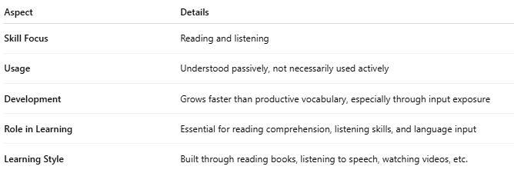
Aspect | Details
Skill Focus | Reading and listening
Usage | Understood passively, not necessarily used actively
Development | Grows faster than productive vocabulary, especially through input exposure
Role in Learning | Essential for reading comprehension, listening skills, and language input
Learning Style | Built through reading books, listening to speech, watching videos, etc.

🧠 Example:
# Source: AI Source: Provided by: [Data Path: Persons Table -> ID Column: 1, Name_En Column: Motasem Essam] -> From: [Chatgpt (GPT-4-turbo)] on [7/30/2025]
- A student reads the word “cautious” in a story and understands it from context
👉 But the same student does not yet use “cautious” in writing or speaking

👤 Who Uses It?
# Source: AI Source: Provided by: [Data Path: Persons Table -> ID Column: 1, Name_En Column: Motasem Essam] -> From: [Chatgpt (GPT-4-turbo)] on [7/30/2025]
- All language users, but especially:
  - Language learners
  - Early-stage ESL students
  - Children acquiring first language
  - Readers expanding vocabulary through exposure

🔄 Receptive vs Productive Vocabulary
# Source: AI Source: Provided by: [Data Path: Persons Table -> ID Column: 1, Name_En Column: Motasem Essam] -> From: [Chatgpt (GPT-4-turbo)] on [7/30/2025]
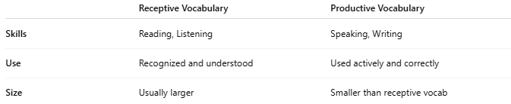
 | Receptive Vocabulary | Productive Vocabulary
Skills | Reading, Listening | Speaking, Writing
Use | Recognized and understood | Used actively and correctly
Size | Usually larger | Smaller than receptive vocab

